|  |  |
| --- | --- |
| **Purpose:** |  |
| **Date:** |  |
| **Coordinates** | |  |  |  | | --- | --- | --- | | **A-P** | **M-L** | **D-V** | |  |  |  | |  |  | Start: | |  |  | End: | |
| **Weight:** |  |
| **Dose:** |  |
| **Volume Injected:** |  |
| **Injection type:** |  |
| **Notes/Bleeding:** |  |

# Prepare virus

# Injection procedure

1. Set up stereotaxic frame.

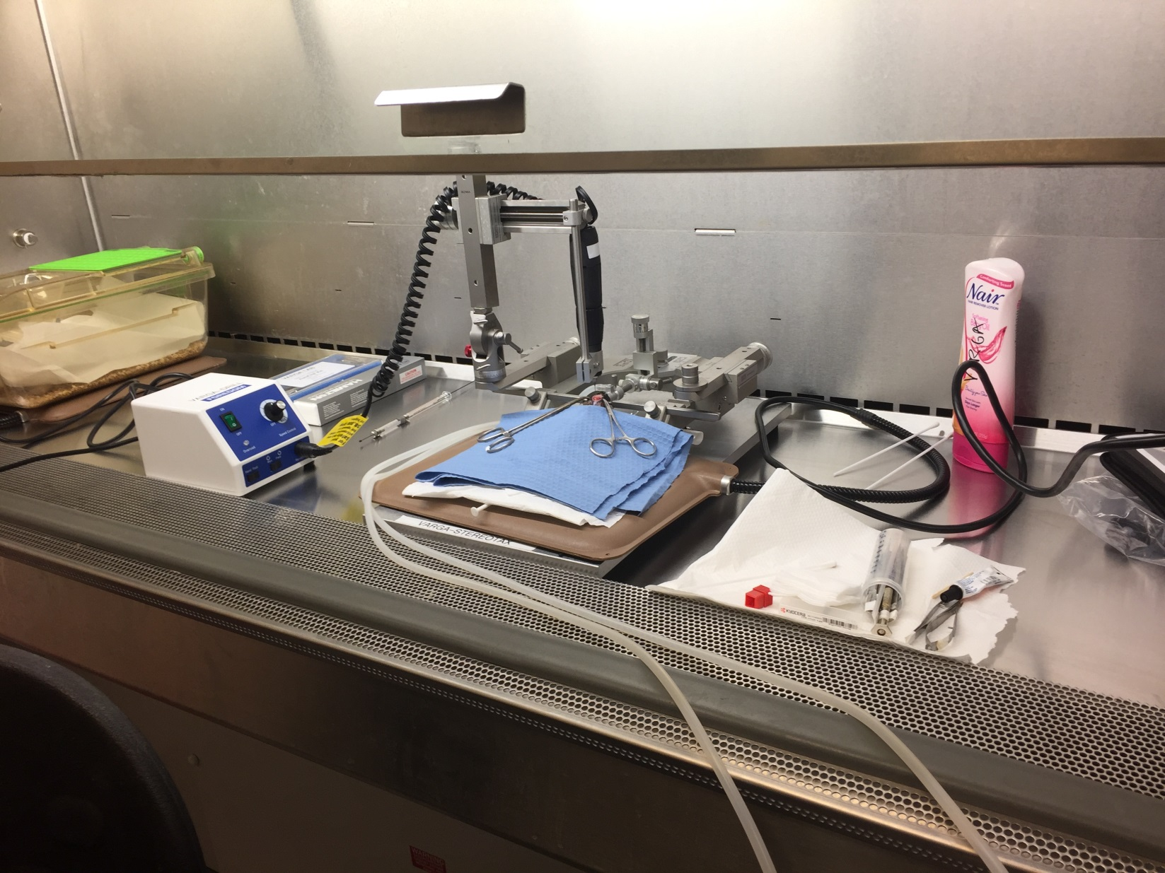

1. Anesthetize and load/prep animal.
2. Nair, inject lactated ringer, apply eye ointment
3. Midline incision, H2O2 skull surface, hemostat skin
4. Set up drill (on left arm), measure Bregma/Lambda, drill holes
5. Lower Isoflurane to 1.5%
6. Load Syringe into Kopf adapter
7. Set up right arm.
8. Attach syringe+adapter:

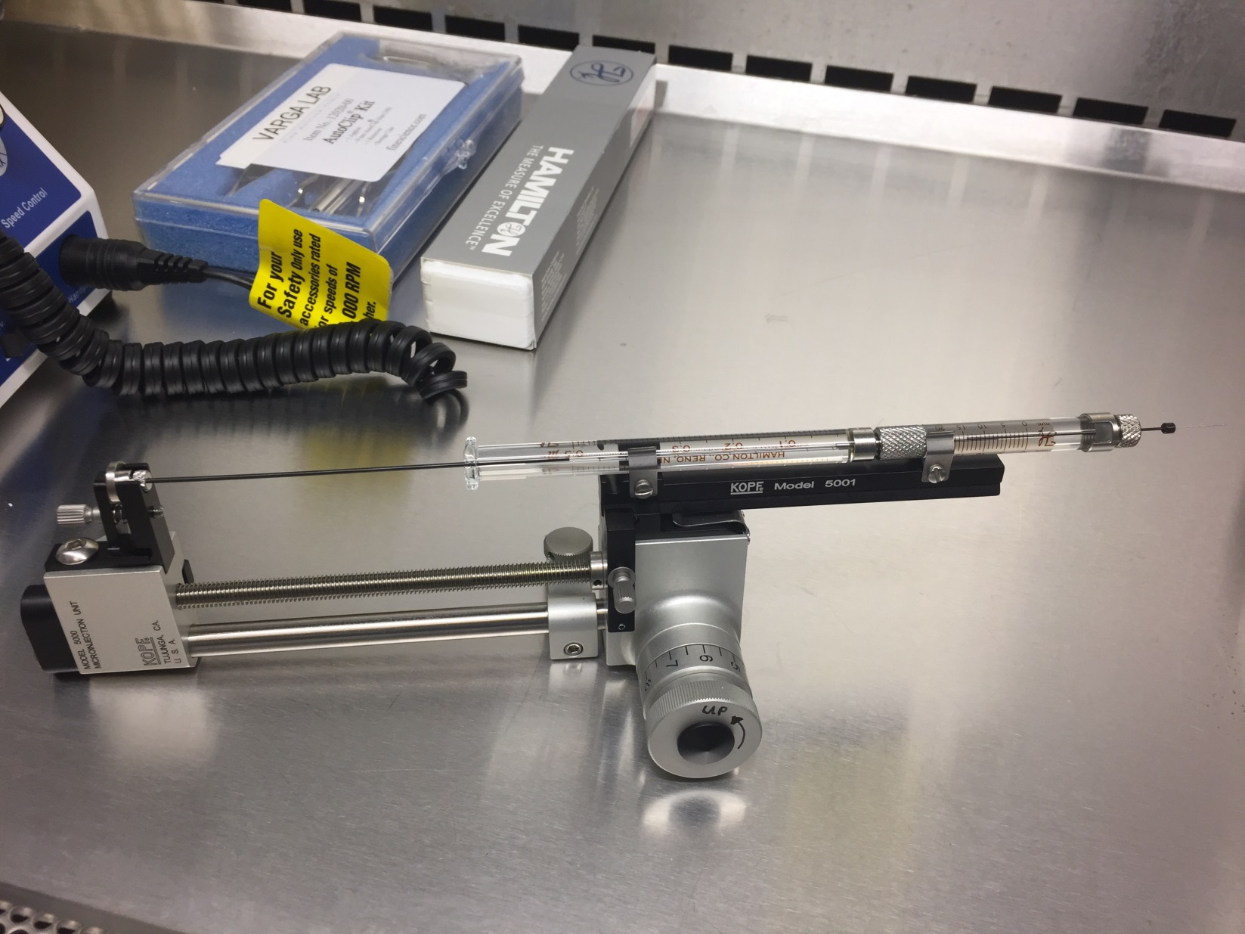

1. Backfill syringe with cargo.
2. Approach Right side bore hole. Zero the “Start Z” coordinate (D-V axis).
3. Go to “End Z -0.02”. Hold for 10 sec. Make pocket for virus.
4. Pull back to “End Z”. Inject manually.
5. Wait 10 min for virus to diffuse:

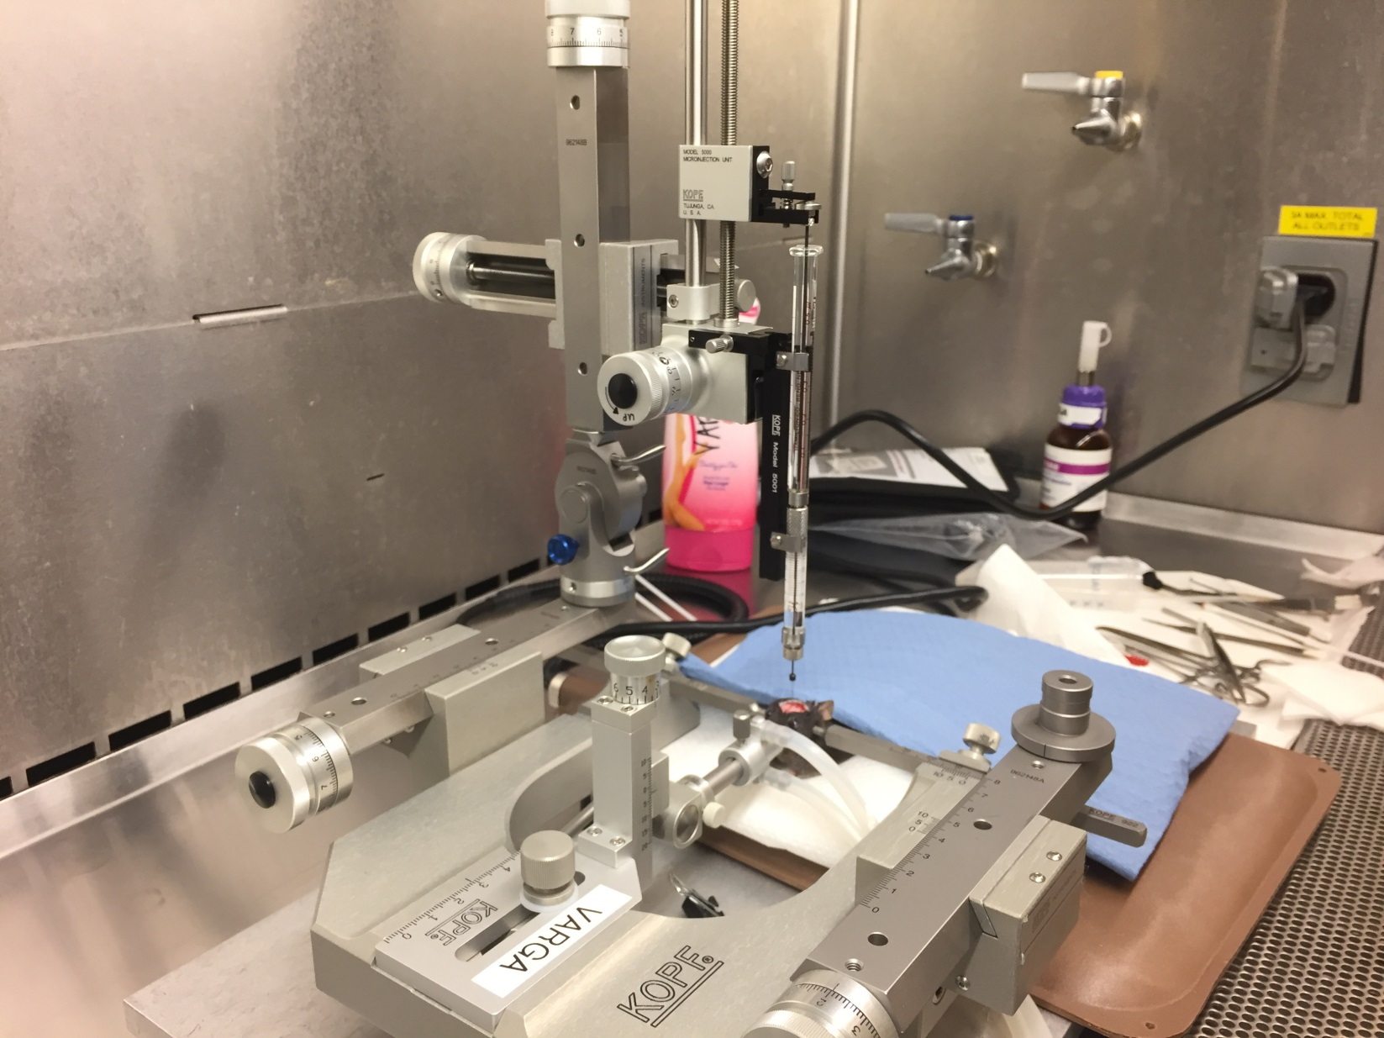

1. Pull back to “End +0.02”. Hold for 5 min.
2. Slowly, pull out of brain.
3. Reload syringe for other injection site.
4. Repeat steps for Left side.
5. Drop isoflurane to 1.0%.
6. When done, apply small drop of cyanoacrylate glue to bore holes.
7. Suture with autoclip.

# Prepare Neuros Syringe

Clean out syringe

Backfill with virus (do this when syringe+adapter is on frame)

# References

1. Direct Intraventricular Delivery of Drugs to the Rodent Central Nervous System
2. Optogenetic interrogation of neural circuits- technology for probing mammalian brain structures
3. Stereotaxic Microinjection of Viral Vectors Expressing Cre Recombinase to Study the Role of Target Genes in Cocaine Conditioned Place Preference